*You are the voice of the economies of the developed nations. Your concern is to keep the money coming in and flowing through the economy of your country. You believe that food security and economic growth interact and are a mutually reinforcing process over the course of development.*

**Background Information:**

* Food assistance is a part of the broader net of social securities provided to citizens of rich nations.
* Government and technological innovations are the heart of economic growth and government interventions to enhance food security reduce the threat of hunger and famine.
* Improved food security stems directly from a set of government policies that integrate the food economy with rapid economic growth and improved income distribution.
* Failure to place food security in a framework of rural-oriented economic growth in combination with policies to stabilize domestic food economies means nothing changes for the hungry.
* Even in developed nations, there is a failure to understand that food security needs to be connected directly to economic growth strategies. Food security must be an objective of national policy.
* $777.8 billion dollars of the United States gross domestic production is based on food/agriculture production
* Policy makers must make policies that create the conditions under which households can gain access to food on a reliable basis through self-motivated interactions between local markets and home resources.
* The economic growth must reach the poor, not just be felt by the rich and middle class if the poor are to experience food security.
* Food insecure children are 2/3rds more likely to experience developmental and emotional delays and illnesses by 3rd grade than food secure children
* Part of the economic plan must take into account the dietary staples of the people and stabilize food prices in general.
* Many economists and politicians do not believe that stabilizing food prices is financially feasible or economically desirable so dismiss and resist efforts of using government interventions to stabilize food prices.
* As well as stabilizing food prices, government policy also needs to provide for access to purchasing power, nutritional knowledge and health care within each household. This assures adequate demand for food in the markets, generating further economic growth.
* Adequate economic growth must occur on both the national level and the individual household level.
* From a developed country’s perspective, it is better economically to ensure food security because it allows consumers worldwide to 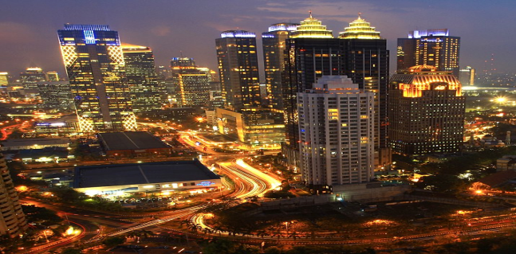have more buying power for “luxury goods” that can be exported, adding additional money to the developed country’s economy.

<https://fbcdn-sphotos-c-a.akamaihd.net/hphotos-ak-ash4/297724_4253096938791_802765261_n.jpg>